CS 499 Milestone Three Narrative
Artifact Overview
The artifact is an Android application that began as the WeightTracker project I created in CS 360 Mobile Architecture and Programming. The original version let users create an account, log in, set a goal weight, and manage weight entries in a local SQLite database. In CS 499, I transformed it into a Cardiac Rehab Progress Tracker that connects my computer science coursework with my professional experience in cardiac rehabilitation. The software engineering enhancement completed in July 2026 created the redesigned dashboard, rehab-session workflow, validation rules, domain model, repository layer, and health-related data fields that became the baseline for this milestone.
Milestone Three focuses on the algorithms and data structures behind the application. The baseline could store and display sessions but did little with them after retrieval. The enhanced version converts each record into a RehabSession object with a real LocalDate, organizes the objects in memory, sorts them chronologically, groups them by week, and calculates progress metrics. The dashboard then shows weekly exercise totals, average weight, peak exercise heart-rate range results, exercise-goal progress, weight change, and goal-weight progress. All information used in the portfolio artifact remains fictional.

Why I Selected the Artifact and How It Was Improved
I selected this artifact because it shows a clear progression from a basic student project into a more complete healthcare-focused application. It also had a meaningful weakness that fit this category. The original WeightTracker mainly retrieved database rows and displayed them one at a time. That demonstrated storage and CRUD operations, but it did not demonstrate how algorithms and data structures can turn a collection of raw records into useful information. Adding a separate analysis layer gave me an opportunity to solve that problem without replacing the work completed during the earlier software engineering enhancement.
The first improvement was changing the session model so the date is represented by LocalDate instead of remaining a plain string. The repository still reads the ISO-formatted value from SQLite, but it converts the value as it creates each RehabSession object. The raw objects are loaded into an ArrayList and passed to RehabProgressAnalyzer. The analyzer makes a defensive copy and uses a comparator to sort sessions by LocalDate, with the newest session first. This keeps date ordering accurate and prevents the dashboard from depending on how SQLite happened to return the rows. The sorting step has O(n log n) time complexity, which is appropriate for a comparison-based sort and more than adequate for the expected number of personal session records.
After sorting, the analyzer makes one pass through the ArrayList and groups each session in a HashMap. I created WeekKey to normalize any session date to the Monday that begins its reporting week. This approach also handles weeks that cross a month or calendar year. Each map value is a temporary accumulator that updates total exercise minutes, session count, total weight, and the number of sessions whose peak exercise heart rate falls inside the entered target range. Resting heart rate remains a separate measurement and is not used in this comparison. A WeeklyProgressSummary is then created with the total minutes, average weight, target-range percentage, and progress toward the application's 150-minute weekly exercise goal. Because HashMap lookup and update are O(1) on average, the grouping stage is O(n) rather than repeatedly scanning the full list for every week.
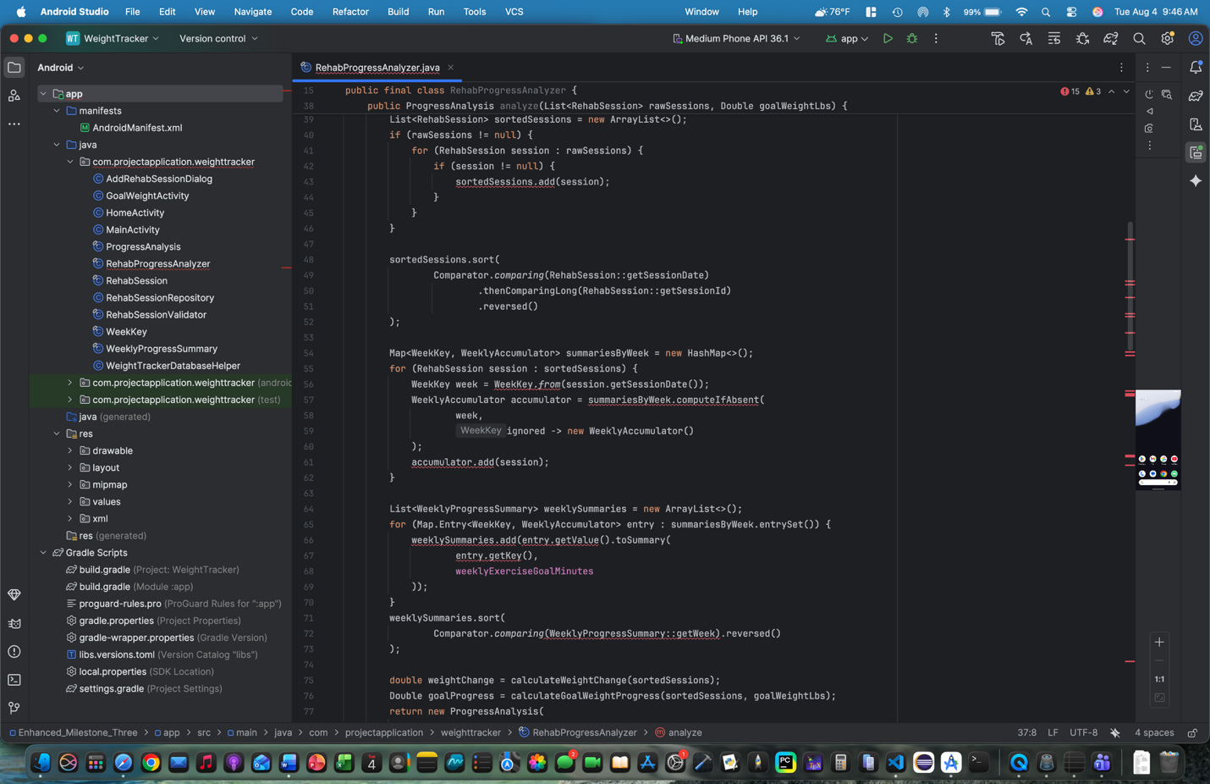
Figure 1. The analyzer sorts a defensive copy of the session list and uses a HashMap to aggregate records efficiently by reporting week.
The weekly results are copied into an ArrayList and sorted newest first because a HashMap does not guarantee display order. The final ProgressAnalysis object exposes immutable lists so the activity cannot accidentally change the analyzer's results. HomeActivity now uses those results to create a weekly progress section on the dashboard. It also displays the change between the first and latest recorded weight and calculates how far the user has moved from the starting weight toward the selected goal. Goal progress is clamped between zero and 100 percent, and reaching or crossing the goal counts as completion. The database version-three migration adds a nullable peak exercise heart-rate field while preserving older sessions. Missing values are excluded rather than counted outside the range. These additions make the artifact useful for reviewing trends instead of only recording individual entries.
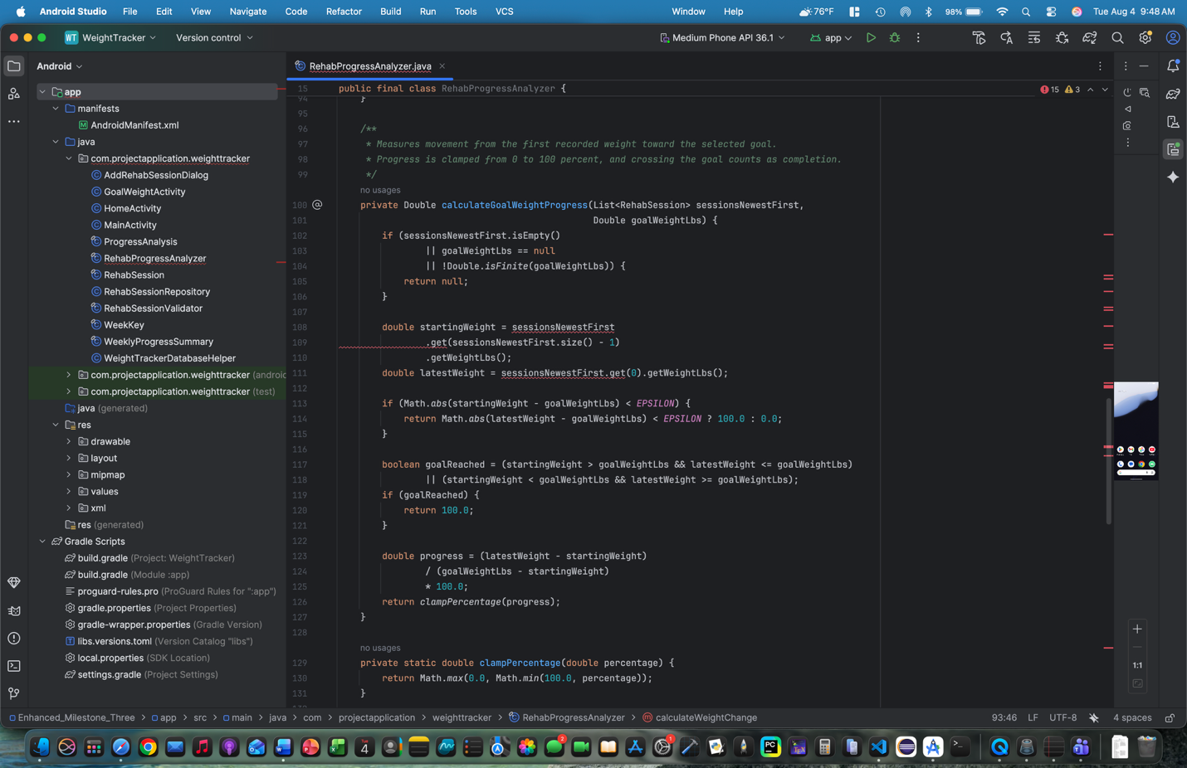
Figure 2. The weight-goal algorithm supports both loss and gain goals while constraining the calculated progress to a meaningful percentage.
I added a focused RehabProgressAnalyzerTest suite to verify the parts of the enhancement that could easily produce incorrect results. The tests check chronological sorting without modifying the input list, weekly totals and averages, target-range percentages, a week that crosses from one year into another, weight-goal calculations, boundary values, empty input, and missing peak measurements. Together with the validation suite, the project has 15 passing unit tests. Testing the analyzer separately from Android interface code made the calculations easier to verify and will make them easier to revise later.

Alignment With Course Outcomes
I met the course outcomes I planned to address in Module One, and I do not need to make a major change to my outcome-coverage plan. Course outcome three is the strongest match for this milestone because I designed and evaluated a computing solution using algorithmic principles and appropriate data structures. The enhancement uses an ArrayList for ordered traversal and sorting, a comparator for accurate date ordering, a HashMap for efficient weekly grouping, custom immutable result objects, and linear aggregation for the progress calculations. I also considered the time and space trade-offs of these choices instead of selecting structures only because they were familiar.
The enhancement also supports outcome one because it turns separate session records into summaries that are easier to use for decision-making. A user can quickly see whether exercise minutes are increasing, how many sessions were completed, how weight is trending, and how often the recorded peak exercise heart rate was inside the entered range. Outcome two is demonstrated by presenting those calculations in readable dashboard cards and by explaining the design and complexity in this narrative. The technical implementation and the user-facing presentation communicate the same information at different levels.
Course outcome four is addressed through the use of Android development, Java, object-oriented design, SQLite integration, unit testing, and healthcare-focused progress analysis to improve the value of the existing application. I kept the current session-card display rather than expanding into a RecyclerView conversion because this milestone's main goal was the analysis pipeline. A RecyclerView and configurable weekly exercise goal remain reasonable future improvements.

Reflection on the Enhancement Process
The most important thing I learned from this enhancement was the difference between storing data and analyzing it. A database query can retrieve and even order records, but that does not automatically demonstrate an application-level algorithm. I deliberately treated the database as the source of the raw records and moved sorting, grouping, and calculations into a separate RehabProgressAnalyzer. This made the responsibilities easier to understand and gave the calculation logic a clear input and output that could be tested without launching the Android application.
Date handling was one of the main challenges. The application stores dates in ISO format, but the earlier model still treated them as strings. Changing RehabSession to use LocalDate meant updating the dialog, repository, dashboard, and tests so they all agreed on where conversion should occur. Grouping by week also required more thought than grouping by month or by a date substring. Normalizing dates to the Monday of each week created a stable key and avoided problems when a week crossed into a new year. I added a specific unit test for that boundary because it would be easy for a simpler week-number approach to separate related sessions.
Another challenge was that the best data structure for grouping was not the best structure for display order. The HashMap makes it efficient to find and update a weekly accumulator, but its iteration order is not predictable. I solved this by using the map for aggregation, then converting the completed summaries into an ArrayList and sorting that list before returning the results. This reinforced that one feature may need more than one data structure and that each structure should be chosen for the part of the problem it handles best.
The weight-goal calculation also required careful handling. A user may be trying to lose or gain weight, may temporarily move away from the goal, or may pass the goal. I used the first recorded weight as the starting point, calculated movement toward the current goal in either direction, and clamped the result to a meaningful percentage. Writing tests for movement away from the goal and for crossing the goal helped confirm that the same formula worked in more than the easiest case.
Overall, this milestone made the artifact much stronger for my ePortfolio because the app now shows a complete flow from stored data to organized objects, calculated summaries, tested results, and a practical dashboard. It also helped me think more carefully about complexity, edge cases, immutability, and the boundary between different layers of an application. Those skills are directly relevant to the type of healthcare software development I want to pursue, where collected information only becomes valuable when it is organized and presented accurately.

